حدد من الصور التالية صور البذور

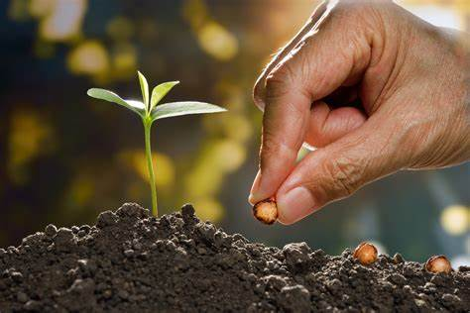

اذكر

خطوات تشتيل البذور

